Rotary Club of Kathmandu Mid-Town
Breakfast Chatter




2 December 2011 The Weekly Bulletin of Rotary Club of Kathmandu Mid-Town Bc-12.2/011-12

District: 3292 Web: www.rotarymidtown.org.np Club Id : 26776

DECEMBER IS THE FAMILY MONTH
Rotarians, clubs, and districts worldwide are encouraged to demonstrate their commitment to family and community through projects, activities, and events in celebration of Family Month .

Friday, 25 November:
2nd Club Assembly
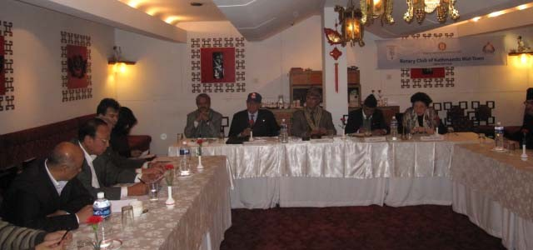
2nd Club Assembly and regular weekly meeting # 1107
conducted by AG PB Limbu and President Som respectively
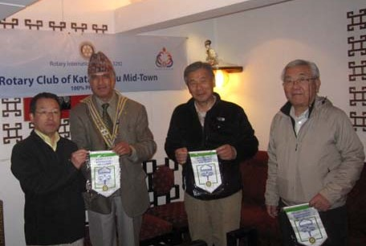
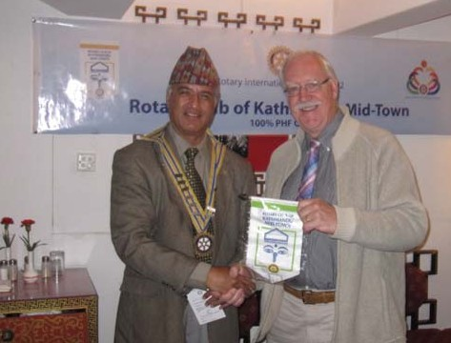
President Som busy in providing Mid-Town flags ?
In the photo (left) three visiting Rotarians from Japan received Mid-Town flags. In another photo (right) visiting Rotarian from UK shaking hand with President Som after receiving the club flag.

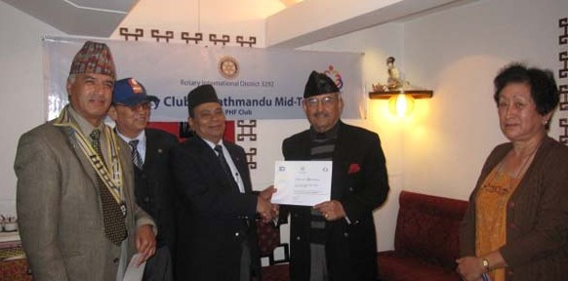
DGE Yogendra handing over PHF+1 to Rtn KNS Thapa .
AG PB Limbu handed over PHF+ certificate to Rtn Dr Chandra Lekha

Weekly Meetings and Programs :
Date | Program/Speaker | Program/Topics of Presentation
2 December 2011 | Dr Donald Sammut | Plastic/ Hand Surgery Experiences
9 December 2011 | DG Visit | District Governor visiting the Club
16 December 2011 | ?
23 December 2011 | Thailand's Ambassador Maris Sangiampongsa | Lessons from Thailand's Rapid Socio-economic Development

2 December, Friday:
Dr Donald Sammut will be talking on Plastic/Hand surgery experiences.

Can you do it ?
A mother made her son wear a sign in public after catching him shoplifting, that said –
Do not trust me,
I will steal from you as
I am a thief
Well, a mother in Townsville, Queensland, Australia did it on 21 Aug 2011 !
Source: The Rising Nepal

What is community service?
When someone performs an action which benefits his or her community, it is known as community service. Some people associate community service with punishment, since it is often offered to small-time offenders as an alternative to fines or jail time. However, community service can also be altruistic, and it is a vital part of many small communities. Getting involved in your community makes it healthier and livelier, and numerous organizations around the world support community service activities.
Things which could be considered community service include tutoring children, building homes in low income areas with habitat for humanity, assisting the elderly, socializing animals at animal shelters, being a museum docent, performing habitat restoration, contributing to the operations of volunteer fire departments and emergency services, or helping with civic beautification. In all cases, community service work is performed by volunteers who are not paid for their time. In some instances, the work would not be accomplished without the work of such volunteers, and many small organizations rely on people with community spirit to survive.
For people who are given community service as a punishment or sentence, it can be an opportunity to atone for a crime. Others engage in community service out of a spirit of altruism, or a desire to connect with their communities by helping out. For people who are new to a community, community service can be a great way to learn more about the place in which they live and the people they live with. Community service may also be required for things like high school graduation or membership in an organization, in which case the school or organization often helps to organize community service opportunities.
Many people engage in community service because they believe that it carries rewards beyond the obvious and tangible. Clearly, engaging in things like environmental restoration and civic beautification will make your life enjoyable by making the world around you more pleasant. But community service can also help to ensure that important services like meals for the elderly and volunteer fire departments continue to run. It also helps to build a rich and supportive community of people who know each other and lend each other a hand when it is needed.

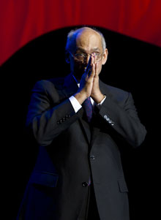
The family is the building block of the community. If we wish to see a world that is more joyous,
we first have to make sure that the families of the world are more joyous, that they have the
things they need to be happy, to thrive, and move forward. So we have to look at housing, at
clean water and sanitation, at health care, at all the issues affecting mothers and children.
RI President Kalyan Banerjee

On Lighter Side : Click here ⇩


Great Quotes:
A person without a sense of humor is like a wagon without springs – jolted by every pebble in the road;
Forty is the old age of youth, fifty is the youth of old age;
Twenty years from now you will be more disappointed by the things that you didn't do than by the ones you did do;
The true sign of intelligence is not knowledge but imagination;
Forget injuries, never forget kindnesses;
Kindness in words creates confidence; kindness in thinking creates profoundness; kindness in giving creates love;
Remember there's no such thing as a small act of kindness. Every act creates a ripple with no logical end.

Please send project/activity information, suggestions and photos etc to :
BC Editor: RR Shrestha email: rryes@wlink.com.np

2 December 2011 The Weekly Bulletin of Rotary Club of Kathmandu Mid-Town bc-12.2/011-12

